ANSI SQL and its importance in database programming.

# What is ANSI SQL?

ANSI SQL (American National Standards Institute Structured Query Language) is a **standardized database query language**. It's essentially a common set of rules, syntax, and guidelines for interacting with relational database management systems (DBMS). Think of it as a universal language that allows different database systems (like MySQL, PostgreSQL, Oracle, Microsoft SQL Server, etc.) to understand and process the same fundamental SQL commands.

The American National Standards Institute (ANSI) and the International Organization for Standardization (ISO) work together to define and evolve these standards. The first SQL standard was established in 1986 (SQL-86), and it has been revised multiple times since (e.g., SQL-92, SQL:1999, SQL:2016) to incorporate new features and improvements.

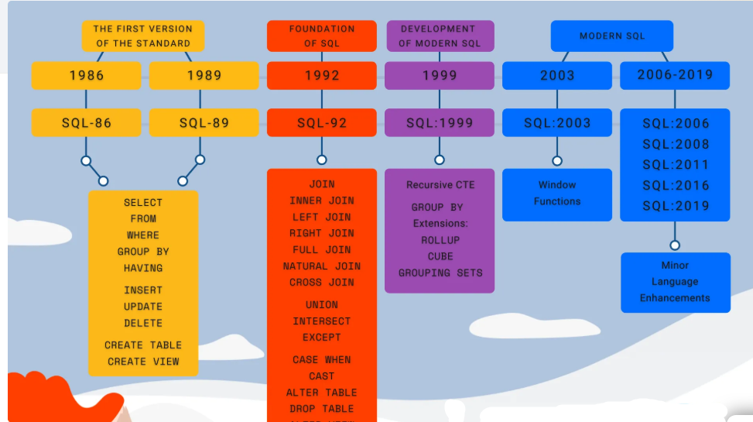

**Why is ANSI SQL important?**

ANSI SQL is crucial for several reasons:

**Standardization:** It provides a consistent framework for SQL, ensuring that code written according to the standard can be executed on different DBMS with little or no modification. This prevents "vendor lock-in," making it easier for businesses to switch or use multiple database systems simultaneously.

**Cross-Platform Interoperability:** By adhering to ANSI SQL, developers can write queries that are compatible with a wide range of major database systems. This reduces the need to learn the specific intricacies and proprietary extensions of each system, simplifying migration and integration efforts.

**Reduced Learning Curve:** For developers and database professionals, learning ANSI SQL provides a strong foundation. The core concepts and syntax are transferable across different database platforms, making it easier to acquire new skills and adapt to various environments.

**Portability:** SQL code written with ANSI compliance in mind is more portable, meaning it can be easily moved and executed on different database systems without significant rewrites. This is particularly valuable in multi-cloud or hybrid-cloud environments.

**Error Detection and Prevention:** ANSI SQL often promotes clearer and more explicit syntax (e.g., ANSI joins with JOIN and ON clauses), which can help prevent accidental errors (like unintended cross joins) and make queries easier to read and debug.

**Long-term Longevity:** Because it's a standard, ANSI SQL provides a stable and well-documented foundation for database operations, ensuring that your SQL code remains relevant and understandable over time.

# Benefits of using ANSI SQL syntax in database programming:

**Increased Code Portability:** As mentioned, code written to ANSI SQL standards is more likely to work across different database platforms with minimal changes.

**Improved Readability and Maintainability:** ANSI SQL often encourages more explicit and structured syntax, which makes the code easier to understand, especially for complex queries and joins. This improves collaboration among developers and simplifies future maintenance.

**Reduced Development Time:** Developers can leverage their knowledge of standard SQL across various projects, reducing the time spent learning vendor-specific syntax or rewriting queries.

**Better Performance (in some cases):** While vendor-specific extensions sometimes offer performance optimizations for specific use cases, well-written ANSI SQL can often be optimized effectively by various database engines. Also, ANSI join syntax often leads to more efficient query plans.

**Easier Debugging:** Clear and standardized syntax makes it easier to pinpoint issues and debug queries, especially when working with complex joins or subqueries.

**Foundation for Advanced Features:** Even though database vendors add proprietary extensions, understanding ANSI SQL provides the essential groundwork for understanding and utilizing those advanced features.

# Different types of SQL (Categories of SQL Commands)

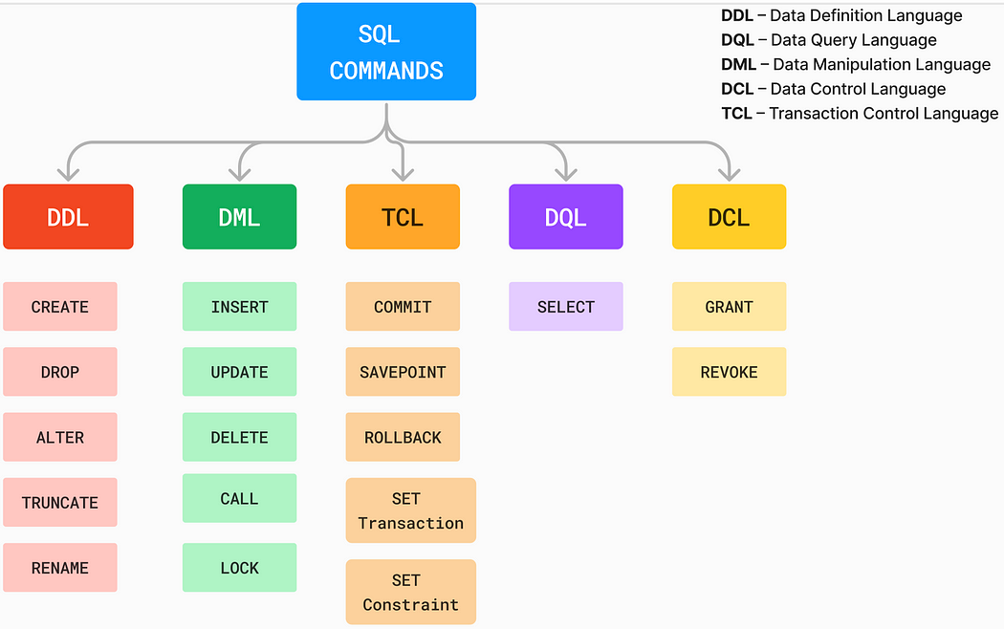

While "types of SQL" can sometimes refer to different SQL *dialects* (like T-SQL for SQL Server or PL/SQL for Oracle), the more common classification refers to the **categories of commands** within SQL, based on their function:

**Data Definition Language (DDL):** These commands are used to define, modify, and manage the structure of database objects (like tables, views, indexes). They deal with the schema of the database.

**CREATE:** Used to create new database objects (e.g., CREATE TABLE, CREATE DATABASE, CREATE INDEX).

**ALTER:** Used to modify the structure of existing database objects (e.g., ALTER TABLE ADD COLUMN, ALTER TABLE DROP COLUMN).

**DROP:** Used to delete database objects (e.g., DROP TABLE, DROP DATABASE).

**TRUNCATE:** Used to remove all records from a table, but keeps the table structure (faster than DELETE for removing all rows).

**Data Manipulation Language (DML):** These commands are used for managing and manipulating data within the database objects.

**INSERT:** Used to add new rows (records) into a table.

**UPDATE:** Used to modify existing data in a table.

**DELETE:** Used to remove rows (records) from a table.

**MERGE:** (Less common but important) Used to conditionally insert, update, or delete rows in a table based on data from another table.

**Data Query Language (DQL):** This category is primarily used for retrieving data from the database.

**SELECT:** The most common DQL command, used to retrieve data from one or more tables. It's the core of querying and analyzing data.

**Data Control Language (DCL):** These commands deal with permissions and access control to the database.

**GRANT:** Used to give users specific privileges or permissions on database objects.

**REVOKE:** Used to remove previously granted privileges.

**Transaction Control Language (TCL):** These commands are used to manage transactions, ensuring data integrity and consistency. A transaction is a single logical unit of work that either completes entirely or fails entirely.

**COMMIT:** Saves all changes made during the current transaction permanently to the database.

**ROLLBACK:** Undoes all changes made during the current transaction, reverting the database to its state before the transaction began.

**SAVEPOINT:** Sets a point within a transaction to which you can later roll back.

In essence, ANSI SQL provides the "blueprint" for how these different types of SQL commands should work, promoting consistency and compatibility across the diverse landscape of relational databases.